Trent Giever

Debbie Wolf

CS 140

2/28/19

Ch 10

1. Creating a Site Using the Business Intelligence Template

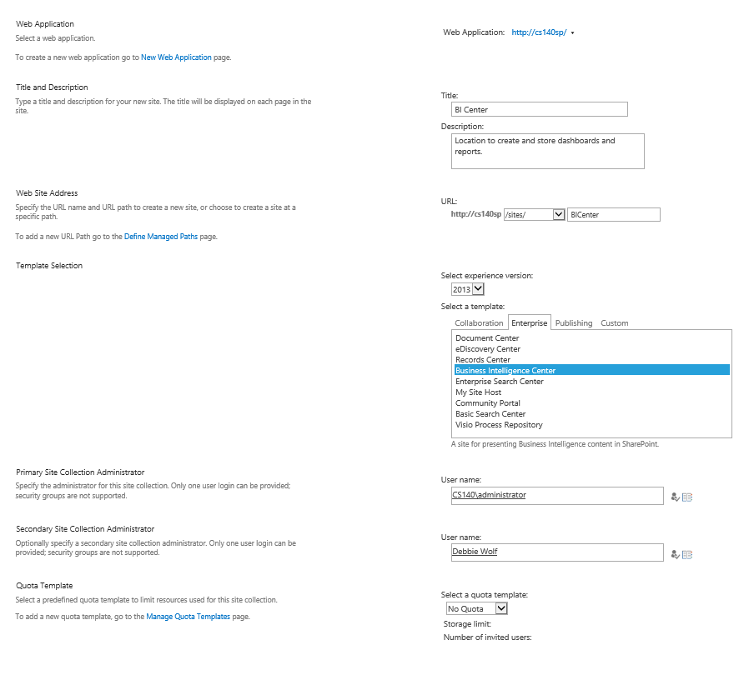

1. Opening and Publishing an Excel Workbook to the SharePoint Library

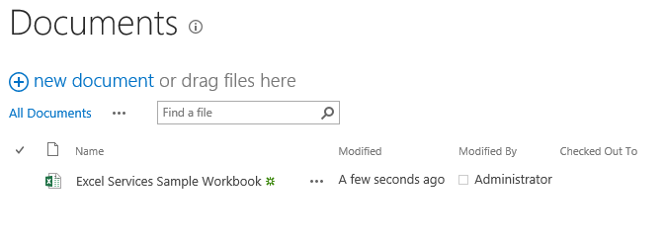

1. Creating a New Dashboard

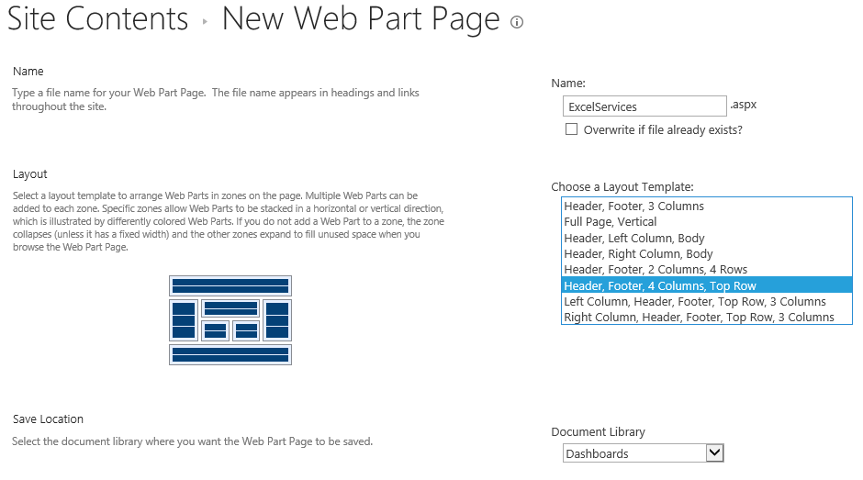

1. Configuring the Excel Services Web Part

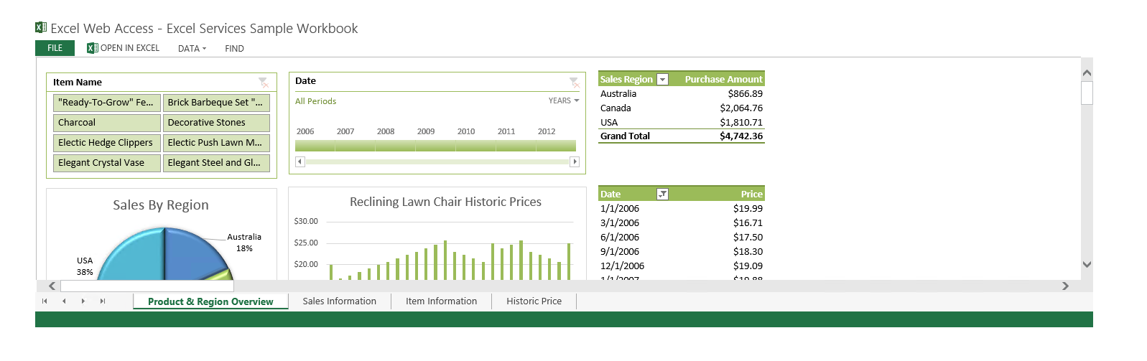

1. Configuring a Parameter Based on Product Name and Connecting with a Filter Web Part  
   **The item name would not add, got an error message, checked the video to see that I was doing it correctly**

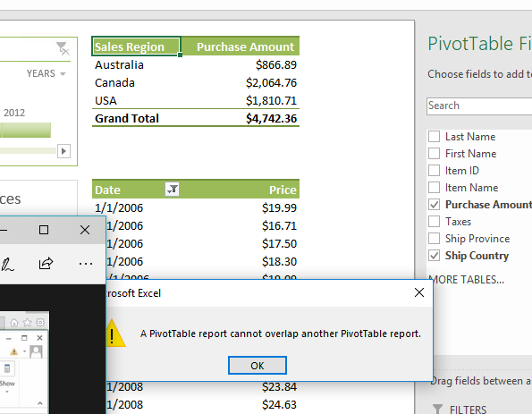

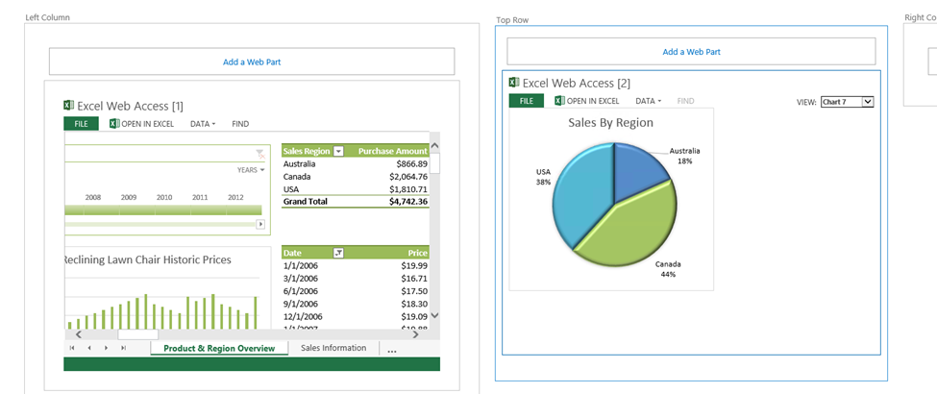

1. Creating a Visio Services Document **I have two files in the additional datafiles folder

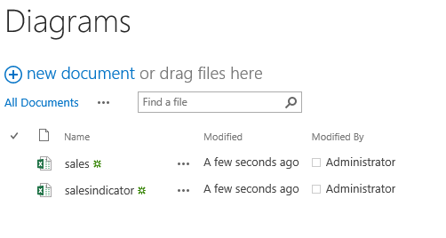

1. Connecting a Visio Services Web Part to a List and Using the List Values as a Web Part Connection

